**Django REST Framework**

Django and Django REST Framework (DRF) are indeed different, but DRF is built on top of Django. Django is a high-level Python web framework that encourages rapid development and clean, pragmatic design. It provides various features and utilities for building web applications, including an ORM (Object-Relational Mapper), URL routing, templating engine, form handling, and more.

Django REST Framework, on the other hand, is an extension to Django that facilitates the development of Web APIs using Django. It adds extra functionality specifically tailored for building RESTful APIs, such as serialization, view classes, authentication, permissions, and more. Essentially, DRF extends Django to make it easier to create APIs that follow the principles of REST.

In summary, Django is a full-stack web framework, while Django REST Framework is an extension of Django specifically designed for building RESTful APIs.

**After installation the directories will look like this:**

project_name/

│

├── manage.py

├── project_name/

│ ├── __init__.py

│ ├── settings.py

│ ├── urls.py

│ └── wsgi.py

│

└── app_name/

├── migrations/

│ └── ...

├── __init__.py

├── admin.py

├── apps.py

├── models.py

├── serializers.py

├── tests.py

├── urls.py

└── views.py

**Here's a brief explanation of the files and directories:**

manage.py: Command-line utility for interacting with your Django project.

project_name/: The main project directory.

__init__.py: An empty file that indicates this directory should be considered a Python package.

settings.py: Configuration settings for your Django project.

urls.py: URL configuration for your project.

wsgi.py: Entry point for WSGI-compatible web servers to serve your Django project.

app_name/: A Django app within your project.

migrations/: Directory to store database migrations.

__init__.py: Package indicator.

admin.py: Configuration for Django's admin interface.

apps.py: Configuration for the app itself.

models.py: Definition of data models for your app.

serializers.py: Serialization classes for Django REST Framework.

tests.py: Unit tests for your app.

urls.py: URL configuration specific to this app.

views.py: Views (controllers) for your app.

After installing Django REST Framework, additional files might include serializers.py for serialization classes and perhaps some modifications or additions to urls.py and views.py to accommodate API endpoints.

**Rules:**

**First, create a virtual env:**

python -m venv myenv

**And activate the environment:**

myenv\Scripts\activate

**And install django:**

pip install Django

**Create project using:**

django-admin startproject project_name

**And Install Django REST Framework:**

pip install djangorestframework or

pipenv install djangorestframework

**and create app in root project folder:**

python manage.py startapp app_name

The command pip install djangorestframework should be executed at the level of your project, not inside any specific app directory. You should navigate to the root directory of your Django project in your terminal or command prompt, and then run the command.

Here's a step-by-step guide:

1. Open your terminal or command prompt.
2. Navigate to the root directory of your Django project using the cd command.
3. Once you're in the root directory of your Django project, run the command pip install djangorestframework.
4. This command will install Django REST Framework globally within your Python environment, making it available for your entire Django project to use.
5. After installing djangoresetframework, Add ”rest_framework” in Installed_Apps in project settings of project.

And also App name.

1. Create **urls.py** file in app folder for routing.
2. Add APP’s urls.py path in project’s urls.py do that Django know that we are using the app’s urls.py for urls.
3. Remember, it's a good practice to execute this command within a virtual environment specific to your project to avoid conflicts with other projects or system-wide Python packages. If you're not using a virtual environment yet, you might consider setting one up.

RESTfulness:

APIs is only RESTfulness if is complies with certains constraints:

**1. Client Server** - The API should use client-server architecture. There should be a server that is serving the resources and there should be a client who consumes them.

**2. Stateless:** A REST API is Stateless, this means that the server does not contain any state of the API client who is making the call so it cannot identify who is making the request or what their previously requested data was without proper user information.

In fact, the State is only saved on the client machine, not on the server and this influences what you should include in your API endpoints or URL Paths

**3.Cacheable**: The APIs should also be cacheabe. This means that responses can be saved by a web browser or a server or any system. This caching process can help to reduce the server load by using the API result from the cache instead of making an actual request to server every time.

**4. Layered**: Layered means that the entire system architecture can be split or decoupled into multiple layers and you should be able to add or remove a layer at any time. Layers of a RESTful API system could include a Firewall, Load balancer, a Web server, and a Database.

**5. Uniform Interface:** it means that the system should offer a uniform communication system to access the resources. For example, there should be unique URLs for each resource. There should also be a unified way to modify or proceed further with a resource from the API result or representation in a standard XML or Jason format.

**6. Code on demand:** code on demand means that the API may deliver some business logic or code that the client can run to further improve the response result.

**Naming conventions** for RESTful APIs help maintain consistency and clarity in your API endpoints, making it easier for developers to understand and work with your API. Here are some common naming conventions:

**1: Use Nouns for Resources:** API endpoints should typically represent nouns, not verbs. For example:

Good: /users, /products, /orders

Avoid: /getUsers, /createProduct, /fetchOrders

**2. Use Plural for Collections:** Use plural nouns to represent collections of resources:

Good: /users, /products

Avoid: /user, /product

**3. Use Singular for Individual Resources:** Use singular nouns to represent individual resources within a collection:

Good: /users/{id}, /products/{id}

Avoid: /user/{id}, /product/{id}

**4. Use Hyphens to Separate Words:** Use hyphens - to separate words within an endpoint for better readability:

Good: /user-profiles, /order-items

Avoid: /userProfiles, /orderitems

**5. Use HTTP Methods for Actions:** Use HTTP methods (GET, POST, PUT, DELETE, etc.) to represent actions on resources rather than including actions in the URL:

Good: POST /users to create a new user

Avoid: /createUser

**6. Use Specific and Intuitive Names:** Endpoint names should be specific and intuitive, reflecting the purpose of the operation:

Good: /users/{id}/orders to retrieve orders associated with a specific user

Avoid: /users/{id}/items

**7. Versioning:** If you need to version your API, consider including the version number in the URL:

Good: /v1/users, /v2/products

Avoid: /users, /products

**8. Consistency:** Maintain consistency throughout your API to make it easier to understand and use. Choose a convention and stick to it across all endpoints.

**9. Case:** Cases like Pascale case, cameCase and snake_case should not be used in API instead, cases like this should be mentioned inside curly braces

/users/{user_id}/orders

**10. No Trailing Slash:** Endpoints should not end with / (forward slash):

Avoid: /users/{user_id}/orders/

**Curl**, **Postman** and **Insomnia** are cross-platform tools to test and debug your APIs

---> While Curl only offers the command line version, it is available in all major operating systems. Similarly, Postman and Insomnia are also available for Windows, macOS and Linux.

---> Postman offers a web version that you can use without installing its desktop client.

**Pipenv** offers a comprehensive solution for Python dependency management by combining the functionality of **pip** and **virtualenv** into a single tool. With features such as automatic virtual environment creation, dependency isolation, and deterministic builds using the **Pipfile** and **Pipfile**.**lock**, **Pipenv** streamlines the development workflow by providing a centralized and integrated approach to managing dependencies. Its advanced dependency resolver and automatic environment activation simplify the process of managing project dependencies, making it a convenient choice for Python developers seeking a robust and efficient dependency management solution.

**Creating Django: New method**

pip install pipenv

pipenv install django

pipenv shell --> This will activate the Virtual environment

pipenv install djangorestframework

django-admin startproject project_name --> This will create a project

cd project_name

python manage.py startapp App_name --> This will create app folder

run: python manage.py runserver --> It will run the Django in local server. The default port number will be ends with 8000, suppose if you want to change the local server port number use this: python manage.py runserver 9000

Go to VS Code -> select folder -> press (ctrl + shift + p) --> select python: select interpreters --> search for shell that has project name.

This is given us a new terminal of our project; from that we can run the local server.

<httpbin.org> - Know about request and response services

**What's curl used for?**

curl is used in command lines or scripts to transfer data. curl is also used in cars, television sets, routers, printers, audio equipment, mobile phones, tablets, medical devices, set top boxes, computer games, media players and is the Internet transfer engine for thousands of software applications in over twenty billion installations.

curl is used daily by virtually every Internet-using human on the globe.

**Security and Authentication in REST API:**

**SSL**: Secure Socket Layer, encrypts your data and protect your data when it leaves your browser and the web server. When you set up the SSL certificates properly your APIs can be served over HTTPS. The frontend and mobile application team that works on the Little Lemon project, want to ensure that the data is transported securely. So, the API team has used SSL certificates from a reputed provider and installed them. Now all the API endpoints are secured and serve data over HTTPS instead of HTTP.

**Signed URLs:** The little Lemon Project team wants to ensure that the API calls are coming to it from their mobile application and their website only. This is where signed URLs come in. Signed URLs give a client application limited access to a specific resource for a brief period of time. With a signed URL, every time an API is called, a particular piece of text called a signature is included with the URL. Server-side code can verify the signature and ensure that the call comes from an authentic source. But how do developers create these signatures? HMAC is a popular signing mechanism used by modern applications. It is easy to use and ensures the authenticity and integrity of the message. For example, some secret message, encoded by a digest algorithm with a secret key, some secret key creates this HMAC signature.

**Cross origin resource sharing or CORS policy:** When you design an API, you can accept calls from everywhere, or by configuring the cores headers, you can only accept calls from some specific domains.

**Firewalls**: If you want to ensure that only specific IP addresses can access your API, you can use a firewall application on your server.

**Access Control:**

A role is a collection of privileges and a privilege is whether you are allowed to do a specific task.

One role can consist of only one privilege or several ones. Whereas a privilege determines whether you are authorized to perform a specific task.You want a role to be made up of detailed and specific privileges that suit the role so that only the right people have access to sensitive information.

**Monitoring**: can help in detection of unusual API call frequency, but it does not help in adding restrictions on them.

**Rate-limiting** limits the number end-user can call your API in a period of time such as per minute, hour or day.

**Authentication versus authorization**

**Introduction**

You need to secure your APIs because they provide third-party clients access to your backend data. If you don’t secure your APIs properly, anyone can tamper with the data and access sensitive information. But even if a client is allowed to access the data, you need to control who can do what. This is where authentication and authorization come in. You now know that although they sound similar, they are not the same. In this reading, you will learn about the difference between authentication and authorization and how you can use it to protect your API endpoints.

**Authentication**

Authentication is the process of verifying the credentials of a user. Logging into websites with a username and password is a typical example of authentication. When the username and password match, the website recognizes the user and sets some cookies in the user’s browser. When the user visits another page on that website, the browser sends those cookies within the HTTP request header. The website recognizes the cookies as well as server-side session data and therefore doesn’t ask for credentials until the user logs out again.

So, how does this work? Token-based authentication usually involves two steps in the API Architecture. First, the client identifies itself with a username and password. Then the API server gives it a bearer token. From there, the client includes the bearer token with every API call that it places. The API server verifies it and then allows the client to perform the action or not. This is where authorization comes in, but more on this later.

If the credentials are not valid, the client will receive a 401 - Unauthorized HTTP status code.

This is like coming to the office on the first day, submitting all your papers and documents, and then receiving your employee card. After that, only your employee card will be sufficient to get inside. Authentication works just like that!

**Authorization**

However, even with your employee card, you will not be able to access all the rooms or spaces in the office. There are some places that are only accessible to a certain group of people who have been given that privilege. Authorization is exactly like that. Authentication lets you in, authorization lets you act. It checks after authentication if the user has the proper privileges to perform some tasks.

On the server side, this is typically done by assigning the user to a group or a set of groups. Then, after verifying the token, the code checks if the user belongs to the appropriate group to perform that task. If not, the client will receive a 403 - Forbidden HTTP status code.

This extra authorization layer in the API architecture ensures that only people with proper privileges can access and modify data. An authorization system in an API project is very important because it prevents data corruption and data breaches.

*FOR DIAGRAM SEE Coursera*

**Exercise**:

**models.py**

from django.db import models

# Create your Book model here.

# Create Meta class inside the Book model

class Book(models.Model):

title = models.CharField(max_length = 255)

author = models.CharField(max_length = 255)

price = models.DecimalField(max_digits= 5, decimal_places = 2)

class Meta:

indexes = [models.Index(fields=['price']),]

def __str__(self) -> str:

return self.title

**views.py**

from django.shortcuts import render

from django.db import IntegrityError

from django.http import JsonResponse

from .models import Book

from django.views.decorators.csrf import csrf_exempt

from django.forms.models import model_to_dict

# Create your views here.

@csrf_exempt

def books(request):

if request.method == "GET":

books = Book.objects.all().values()

return JsonResponse({"Books": list(books)})

if request.method == "POST":

title = request.POST.get("title")

author = request.POST.get("author")

price = request.POST.get("price")

book =Book(title = title, author = author, price = price)

try:

book.save()

except IntegrityError():

return JsonResponse({'error':'true','message':'required field missing'},status=400)

return JsonResponse(model_to_dict(books), status = 201)

**urls.py ->app**

from django.urls import path

from . import views

urlpatterns = [

path('books/', views.books, name = "books"),

]

**urls.py -> project**

"""BookList URL Configuration

The `urlpatterns` list routes URLs to views. For more information please see:

https://docs.djangoproject.com/en/4.1/topics/http/urls/

Examples:

Function views

1. Add an import: from my_app import views

2. Add a URL to urlpatterns: path('', views.home, name='home')

Class-based views

1. Add an import: from other_app.views import Home

2. Add a URL to urlpatterns: path('', Home.as_view(), name='home')

Including another URLconf

1. Import the include() function: from django.urls import include, path

2. Add a URL to urlpatterns: path('blog/', include('blog.urls'))

"""

from django.contrib import admin

from django.urls import path, include

urlpatterns = [

path('admin/', admin.site.urls),

path('api/', include('BookListAPI.urls')),

]

**Output:**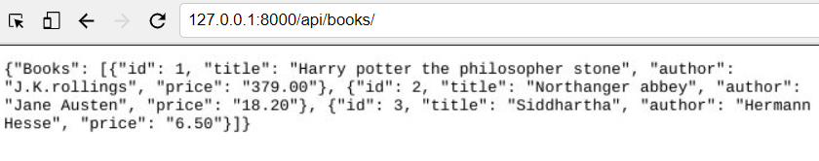

**Mocking APIs** is a common practice in software development, especially during the early stages of development when the actual APIs might not be available or fully implemented yet. Mocking allows developers to simulate API responses and behavior, enabling them to continue development without being dependent on the real API.

**Here's a general approach to mocking APIs:**

**1. Identify Endpoints and Data Structures:**

First, identify the endpoints you need to mock and the structure of the data they return. This includes understanding the request and response formats, HTTP methods, and any authentication mechanisms.

**2. Choose a Mocking Library or Tool:**

There are several libraries and tools available for mocking APIs in various programming languages. Some popular options include:

JSON Server: A full fake REST API with zero coding in JavaScript. It's easy to set up and configure.

MockServer: A flexible mock server and proxy that enables easy mocking of HTTP/HTTPS and system behaviors.

WireMock: A flexible library for stubbing and mocking web services.

pytest-mock: A plugin for the pytest testing framework that provides mocking and spying capabilities.

unittest.mock (Python): A built-in module in Python's standard library for mocking objects and functions.

Choose the one that best fits your project requirements and programming language.

**3. Create Mock Endpoints and Responses:**

Using the chosen mocking library or tool, create mock endpoints that mimic the behavior of the real API endpoints. This involves defining the expected request patterns and generating appropriate responses. You can hardcode sample data or use libraries to generate random or realistic-looking data.

**4. Integrate Mocks into Your Development Environment:**

Integrate the mock API endpoints into your development environment. This might involve running the mock server locally or configuring your code to use the mock endpoints during development.

**5. Implement and Test Against Mocks:**

Modify your client-side code to make requests to the mock API endpoints instead of the real ones. Test your code against the mock endpoints to ensure that it behaves as expected and handles the responses correctly.

**6. Update as Needed:**

As the real API endpoints become available or change over time, update your mock endpoints to reflect these changes. This ensures that your development environment remains in sync with the actual API behaviour.

By following these steps, you can effectively mock APIs and continue development smoothly even when the real APIs are unavailable or undergoing changes**.**

**API endpoints** are specific URLs within a web API (Application Programming Interface) that are used to interact with resources or perform operations. Each endpoint represents a different functionality or resource provided by the API. These endpoints typically accept HTTP requests (such as GET, POST, PUT, DELETE) and return HTTP responses containing data or status codes.

Here are some key characteristics of API endpoints:

**Uniform Resource Locator (URL):** An API endpoint is identified by a URL that clients can use to access the resource or perform an operation. The URL usually follows a consistent pattern and includes the hostname, path, and sometimes query parameters.

**HTTP Methods:** API endpoints support various HTTP methods (e.g., GET, POST, PUT, DELETE) to perform different actions on the resource. Each HTTP method corresponds to a specific operation, such as retrieving data (GET), creating a new resource (POST), updating an existing resource (PUT/PATCH), or deleting a resource (DELETE).

**Resource Representation:** API endpoints define how resources are represented in requests and responses. For example, endpoints may accept data in JSON or XML format in request bodies and return data in the same format in response bodies.

**Status Codes:** API endpoints return HTTP status codes to indicate the success or failure of a request. Common status codes include 200 OK (successful request), 201 Created (resource created successfully), 400 Bad Request (invalid request), 404 Not Found (resource not found), and 500 Internal Server Error (server error).

**Authentication and Authorization:** Endpoints may require authentication and authorization to access certain resources or perform specific actions. Authentication mechanisms such as API keys, tokens, or OAuth are used to authenticate clients, while authorization rules control which users or clients have permission to access specific endpoints.

**Documentation**: API endpoints are typically documented to provide information about their purpose, supported HTTP methods, expected request and response formats, authentication requirements, and any additional parameters or headers required.

**Benefits of Using** @api_view() **from “**from rest_framework.decorators import api_view”:

1. It allows you to use other helpful policy decorators like **permission_classes** and **throttle_classes**
2. It turns standard API output into a browsable API interface.
3. It allows you to specify which HTTP methods a function should support. You can do this by passing all those HTTP method names as an array to the API view decorator function. @api_view([‘POST’, ‘GET’])
4. It includes helpful information in the output about the current API endpoint such as which renderer DRF is used to display the API output, what types of data this API accepts, and so on.

**models.py**

from django.shortcuts import render

from rest_framework.response import Response

from rest_framework import status

from rest_framework.decorators import api_view

# from django.http import HttpResponse

# Create your views here.

# We can use Httpresponse instead of Response without using api_view but we will get the plain text as output.

@api_view(['POST', 'GET']) # We can give POST or GET or PUT request for testing API in Insomnia application, so that that will the request when testing

def books(request):

return Response("List of the books:",

status = status.HTTP_200_OK)

**urls.py (app)**

from django.urls import path

from . import views

# URLs

urlpatterns = [

path('books/', views.books, name = 'books'),

]

**urls.py (project)**

path('api/', include('App.urls')),

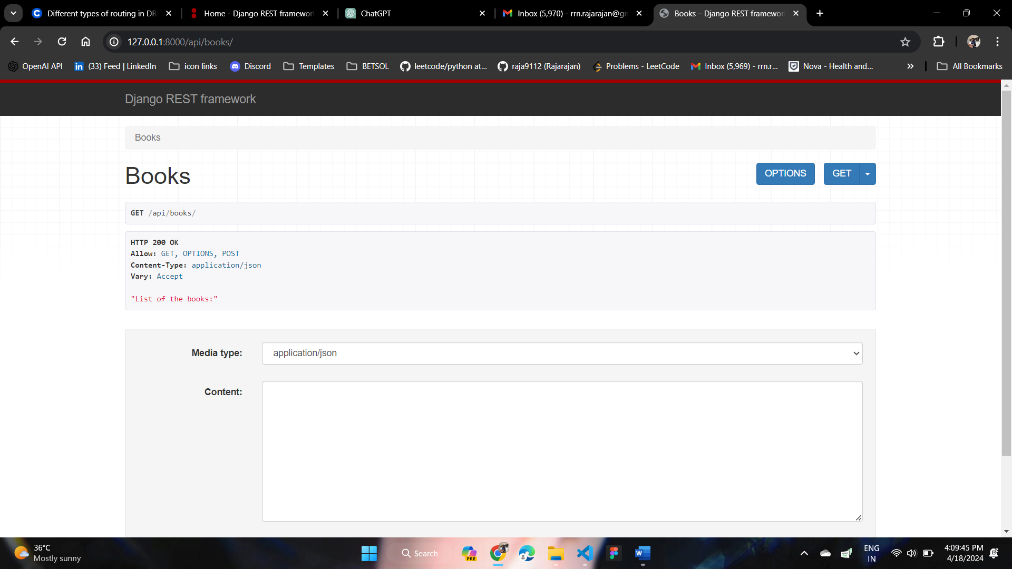

In **Django REST Framework (DRF), views** are responsible for processing incoming HTTP requests and returning appropriate HTTP responses. There are two main types of views in DRF: function-based views (FBVs) and class-based views (CBVs). Here are six key differences between them:

**Implementation Style:**

Function-Based Views (FBVs): FBVs are simple Python functions that take a request object as input and return a response object. They are defined using the @api_view decorator from DRF.

Class-Based Views (CBVs): CBVs are Python classes that inherit from one of the generic view classes provided by DRF, such as APIView, GenericAPIView, or specific mixins and viewsets. They use methods such as get(), post(), put(), delete(), etc., to handle different HTTP methods.

**Code Reusability:**

FBVs: FBVs can lead to code duplication if similar logic needs to be repeated across multiple views. However, you can mitigate this by creating utility functions or decorators.

CBVs: CBVs encourage code reuse through class inheritance and mixins. Common functionality can be implemented in base classes and reused across multiple views.

**Complexity and Readability:**

FBVs: FBVs are often simpler and more straightforward, especially for small or straightforward views. They are easier to understand for developers who are new to DRF or Django.

CBVs: CBVs can be more complex and may require a deeper understanding of object-oriented programming concepts. However, they can offer more flexibility and extensibility for complex views and applications.

**Built-in Features:**

FBVs: FBVs provide basic functionality for creating API views but may require additional code to implement features like pagination, filtering, or authentication.

CBVs: CBVs come with built-in support for common patterns and features, such as pagination, filtering, authentication, permissions, and viewsets. They provide a higher level of abstraction and encapsulation of common behavior.

**View Composition:**

FBVs: FBVs are typically standalone functions that handle a specific endpoint or action. They are easy to compose together using decorators or utility functions.

CBVs: CBVs encourage the use of mixins and inheritance to compose views from smaller, reusable components. This allows for more modular and structured code organization.

**Community Preference:**

FBVs: FBVs have been the traditional way of defining views in Django and are still widely used, especially for simple or one-off views.

CBVs: CBVs have become increasingly popular in DRF due to their built-in features, code organization benefits, and support for more complex use cases. They are recommended for larger or more complex projects where code organization and maintainability are important.

Models.py

from rest_framework.views import APIView

class bookList(APIView):

def get(self, request):

author = request.GET.get('author')

if author:

return Response({"Author of the book: " + author}, status = status.HTTP_200_OK)

return Response({"List of books: "}, status = status.HTTP_200_OK)

def post(self, request):

return Response({f"The title of the book: {request.data.get('title')}"}, status = status.HTTP_201_OK)

App/ urls.py : path('booklist/', views.bookList.as_view(), name = "Book_list"),

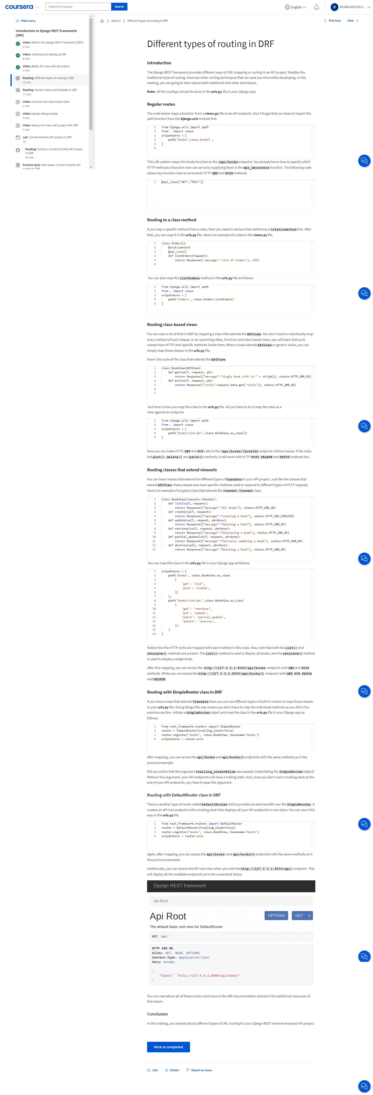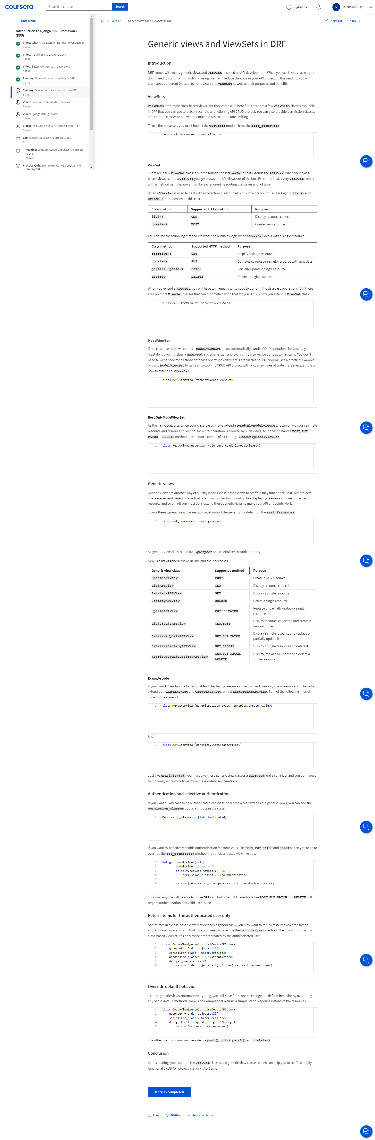

**Django Debug Toolbar:**

The Django Debug Toolbar is a configurable set of panels that display various debug information about the current request/response and your Django project. It's a valuable tool for debugging and optimizing Django applications during development. Here are some key features and functionalities of the Django Debug Toolbar:

**Request/Response Panels:**

Displays detailed information about the HTTP request and response, including headers, cookies, query parameters, and session data.

**SQL Query Panel:**

Shows the SQL queries executed during the request, along with the time taken for each query. This panel helps identify potential performance bottlenecks in your database queries. used to check for performance tuning and optimization by detect if more than the required SQL queries are running and then take the necessary steps to fix them.

**Template Panel:**

Lists the templates rendered during the request, along with the context data passed to each template. Useful for debugging template rendering issues and inspecting context variables.

**Cache Panel:**

Provides information about cache hits and misses, as well as the time spent retrieving data from the cache. Helpful for optimizing caching strategies and diagnosing cache-related issues.

**Signals Panel:**

Displays signals sent and received during the request, such as model signals and custom signals defined in your project. Useful for tracking the flow of data and events within your application.

**Logging Panel:**

Shows log messages generated during the request, including messages logged using Python's logging module. Helps diagnose issues and monitor application behavior.

**Settings Panel:**

Lists Django settings used during the request, making it easy to verify configuration settings and troubleshoot configuration-related issues.

**Profiling Panel:**

Provides a graphical representation of the time spent in various parts of the request/response cycle, helping identify performance hotspots in your code.

**SQL Explorer:**

Allows you to interactively explore and execute SQL queries from within the debug toolbar interface, making it easier to analyze database performance and troubleshoot SQL-related issues.

**Toolbar Customization:**

The debug toolbar is highly customizable, allowing you to enable/disable specific panels, reorder panels, and configure various settings to suit your development workflow and preferences.

CMD: pipenv install django-debug-toolbar

In Settings, Add 'debug_toolbar' in INSTALLED_APP and add ‘debug_toolbar.middleware.DebugToolbarMiddleware’ in MIDDLEWARE settings.

Add path('__debug__/', include('debug_toolbar.urls')), in Project/urls.py

And add new section in settings.py to include local ip address called 🡪 INTERNAL_IPS = [ ‘127.0.0.1’ ]

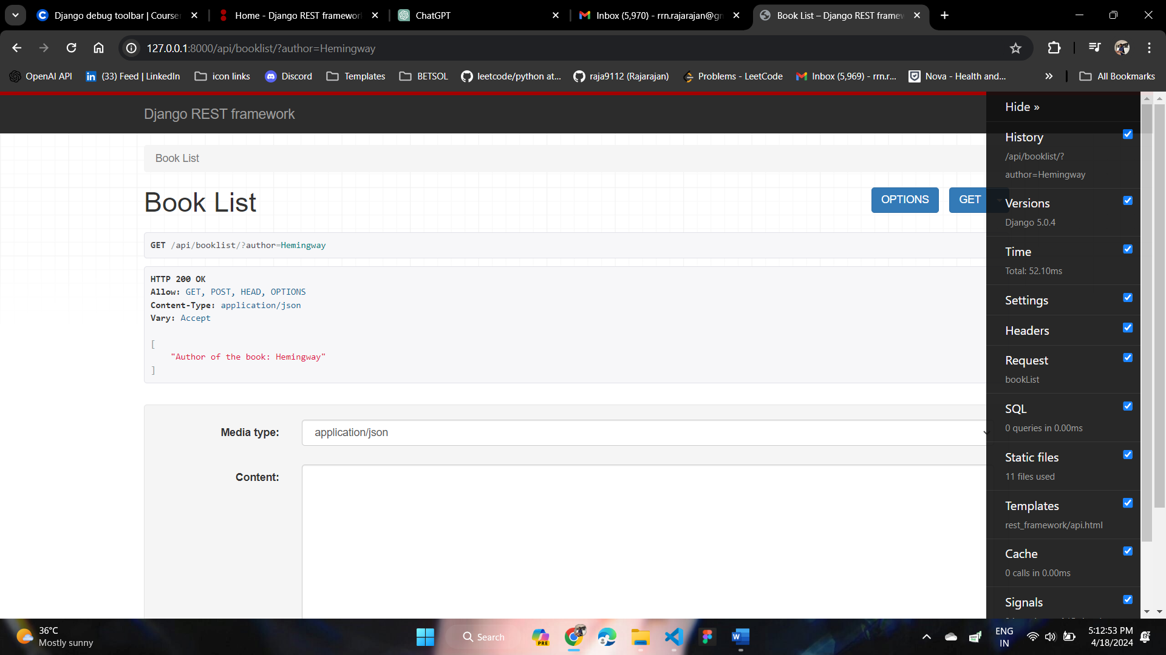

In **Django REST Framework (DRF), serialization and deserialization** are core concepts used to convert complex data types (such as Django model instances) into native Python data types (serialization) and vice versa (deserialization). This process is essential for handling request data, validating input, and formatting responses in a RESTful API.

Let’s consider we have the following model.py

# models.py

from django.db import models

class MyModel(models.Model):

name = models.CharField(max_length=100)

description = models.TextField()

**Serialization**:

Serialization refers to the process of converting complex data types (e.g., Django model instances) into native Python **data types (e.g., dictionaries or JSON) that can be easily rendered into HTTP responses.**

**Here's an example of serialization using DRF:**

from rest_framework import serializers

from .models import MyModel

class MyModelSerializer(serializers.ModelSerializer):

class Meta:

model = MyModel

fields = ['id', 'name', 'description']

**Output:**

{

"name": "Example Name",

"description": "Example Description"

}

**In this example:**

* We define a serializer class MyModelSerializer that inherits from serializers.ModelSerializer.
* We specify the model as MyModel and the fields to include in the serialized representation.
* DRF automatically generates serialization logic based on the model fields.

**Deserialization**:

Deserialization is the process of converting native Python data types (e.g., dictionaries or JSON) received from HTTP requests into complex data types (e.g., Django model instances) that can be processed and saved in the database.

Here's an example of deserialization using DRF:

from rest_framework import serializers

from .models import MyModel

class MyModelSerializer(serializers.ModelSerializer):

class Meta:

model = MyModel

fields = ['id', 'name', 'description']

def create(self, validated_data):

return MyModel.objects.create(**validated_data)

**In this example:**

* We define a serializer class MyModelSerializer with a create method.
* The create method is responsible for creating a new MyModel instance based on the validated data received from the HTTP request.
* Usage:
* To use serialization and deserialization in DRF, you typically create serializer classes for your models and then use them in views or viewsets to handle incoming requests and outgoing responses.

**For example, in a DRF view:**

from rest_framework.views import APIView

from rest_framework.response import Response

from .serializers import MyModelSerializer

class MyView(APIView):

def post(self, request):

serializer = MyModelSerializer(data=request.data)

if serializer.is_valid():

serializer.save()

# instance = serializer.save()

# print(instance.id) # Output: The ID of the newly created instance

return Response(serializer.data, status=201)

return Response(serializer.errors, status=400)

**User input:**

request = {

"name": "Example Name",

"description": "Example Description"

}

**In this view:**

* We instantiate the serializer with data=request.data to deserialize the incoming request data.
* We check if the data is valid using serializer.is_valid().
* If valid, we save the data using serializer.save().
* Finally, we return a response with either the serialized data or errors.

Adding method in serializers to change the value of attributes from models.py:

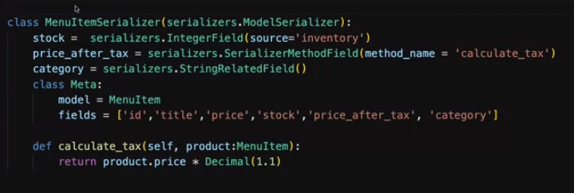

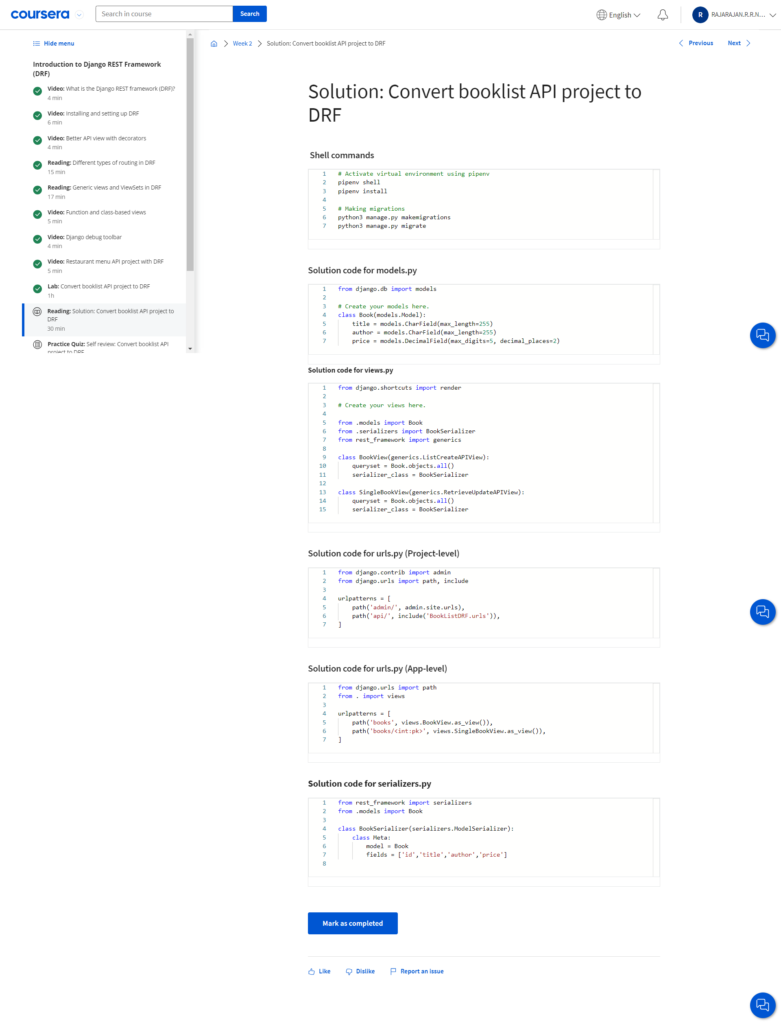

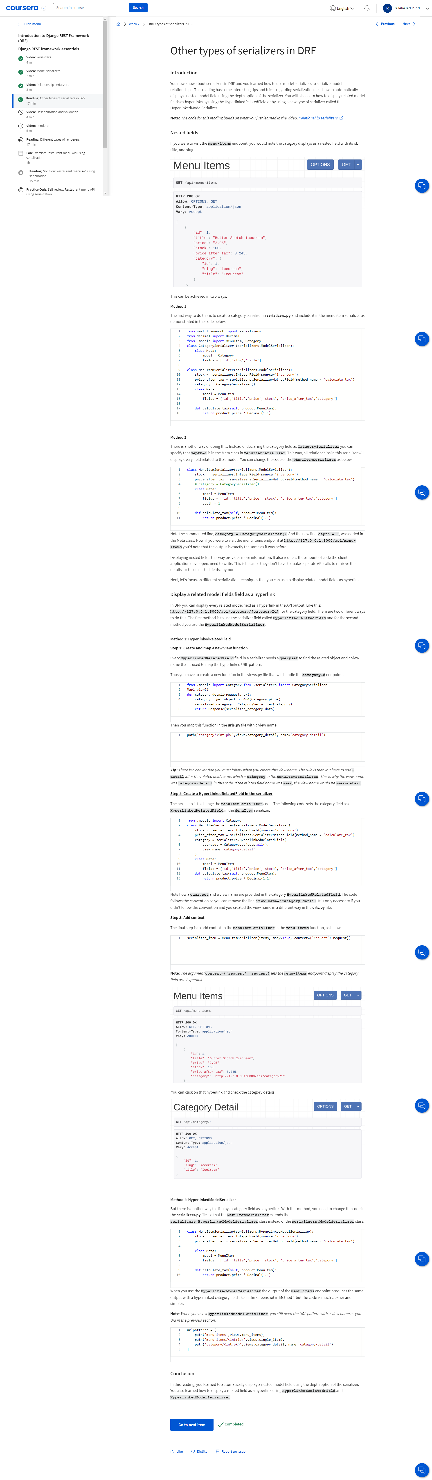

**Renderers:**

In Django REST Framework (DRF), renderers are components responsible for converting Python data types (such as dictionaries or queryset instances) into a specific format (e.g., JSON, XML) that can be returned in HTTP responses. Renderers are used to serialize data before sending it over the network in API responses. DRF provides several built-in renderers, each tailored to a specific data format. Here are some commonly used renderers in DRF:

**JSONRenderer:**

Converts Python data into JSON format. This is the default renderer used by DRF for rendering API responses.

**TemplateHTMLRenderer:**

Renders data into an HTML template using Django's template engine. This renderer is useful for rendering HTML responses for web browsers.

**BrowsableAPIRenderer:**

Renders API responses in a browsable HTML format, providing an interactive API browser that allows users to navigate and interact with the API.

**AdminRenderer:**

Renders data in a format suitable for displaying in Django's admin interface. This renderer is often used for admin views or custom admin actions.

**XMLRenderer:**

Converts Python data into XML format. This renderer is useful when interacting with systems that require XML-based APIs.

**CSVRenderer:**

Converts Python data into comma-separated values (CSV) format. This renderer is handy for exporting tabular data from APIs.

**YAMLRenderer:**

Converts Python data into YAML format. YAML (YAML Ain't Markup Language) is a human-readable data serialization format.

**ExcelRenderer:**

Converts Python data into Microsoft Excel format (.xls or .xlsx). This renderer is useful for exporting data in spreadsheet format.

**PDFRenderer:**

Converts Python data into Portable Document Format (PDF). This renderer is useful for generating PDF reports or documents from API data.

**\*\*\* We should set Accept header in the HTTP request to set the type of content we want from the API if we don’t send and Accept header, only the JSON output will display\*\*\***

**\*\*\*import library to set default renderers in settings.py\*\*\*** import rest_framework.renderers

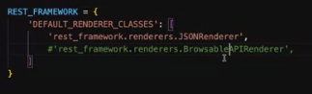

Output:

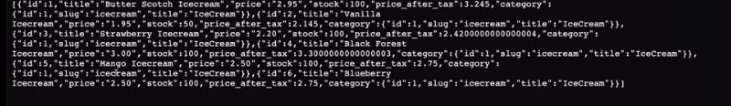

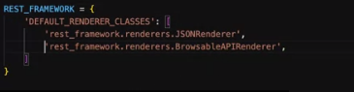

Output:

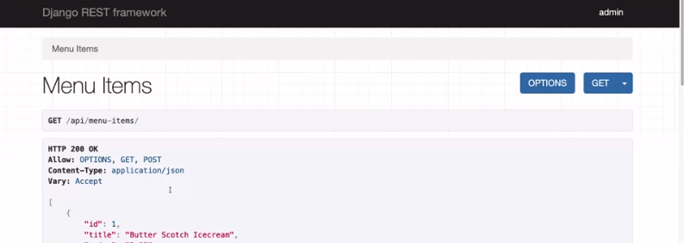

The browsable API view works only when the Accept header is set to text/html. And this is the header that browser sent by default. But if this header is not set, DRF returns only the JSON output. 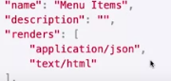

And for the new content type xml rendered, we need to install package pipenv install djangorestframework-xml and need to add rest_framework_xml.renderers.XMLRenderer in settings.py

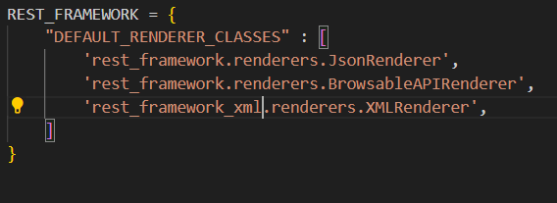

After adding XMLRenderer, checking in Insomnia by adding header as “application/xml” instead application/json or html and getting output

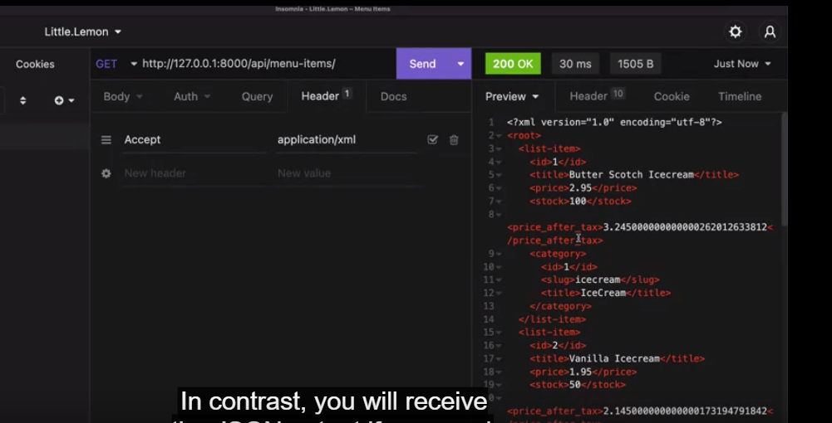

With Json:

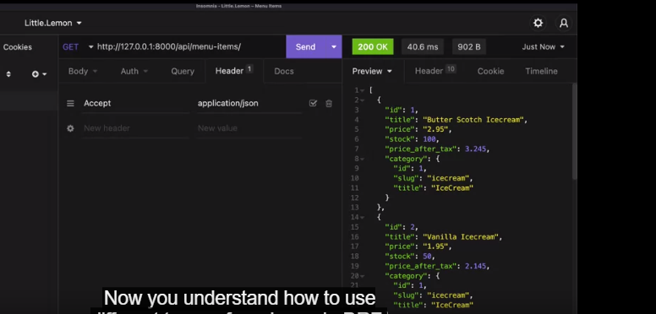

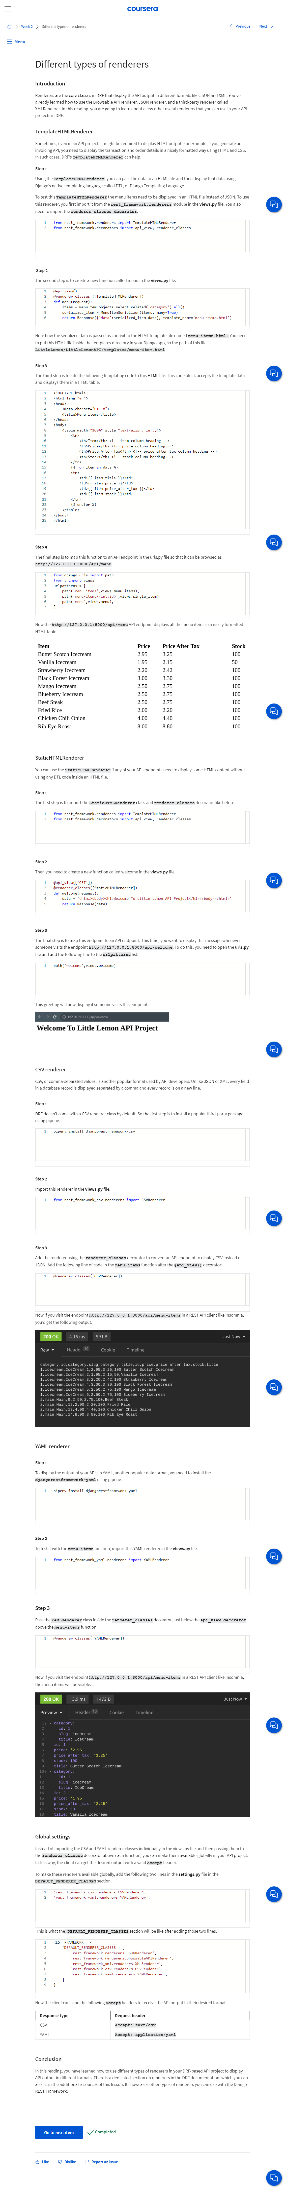 

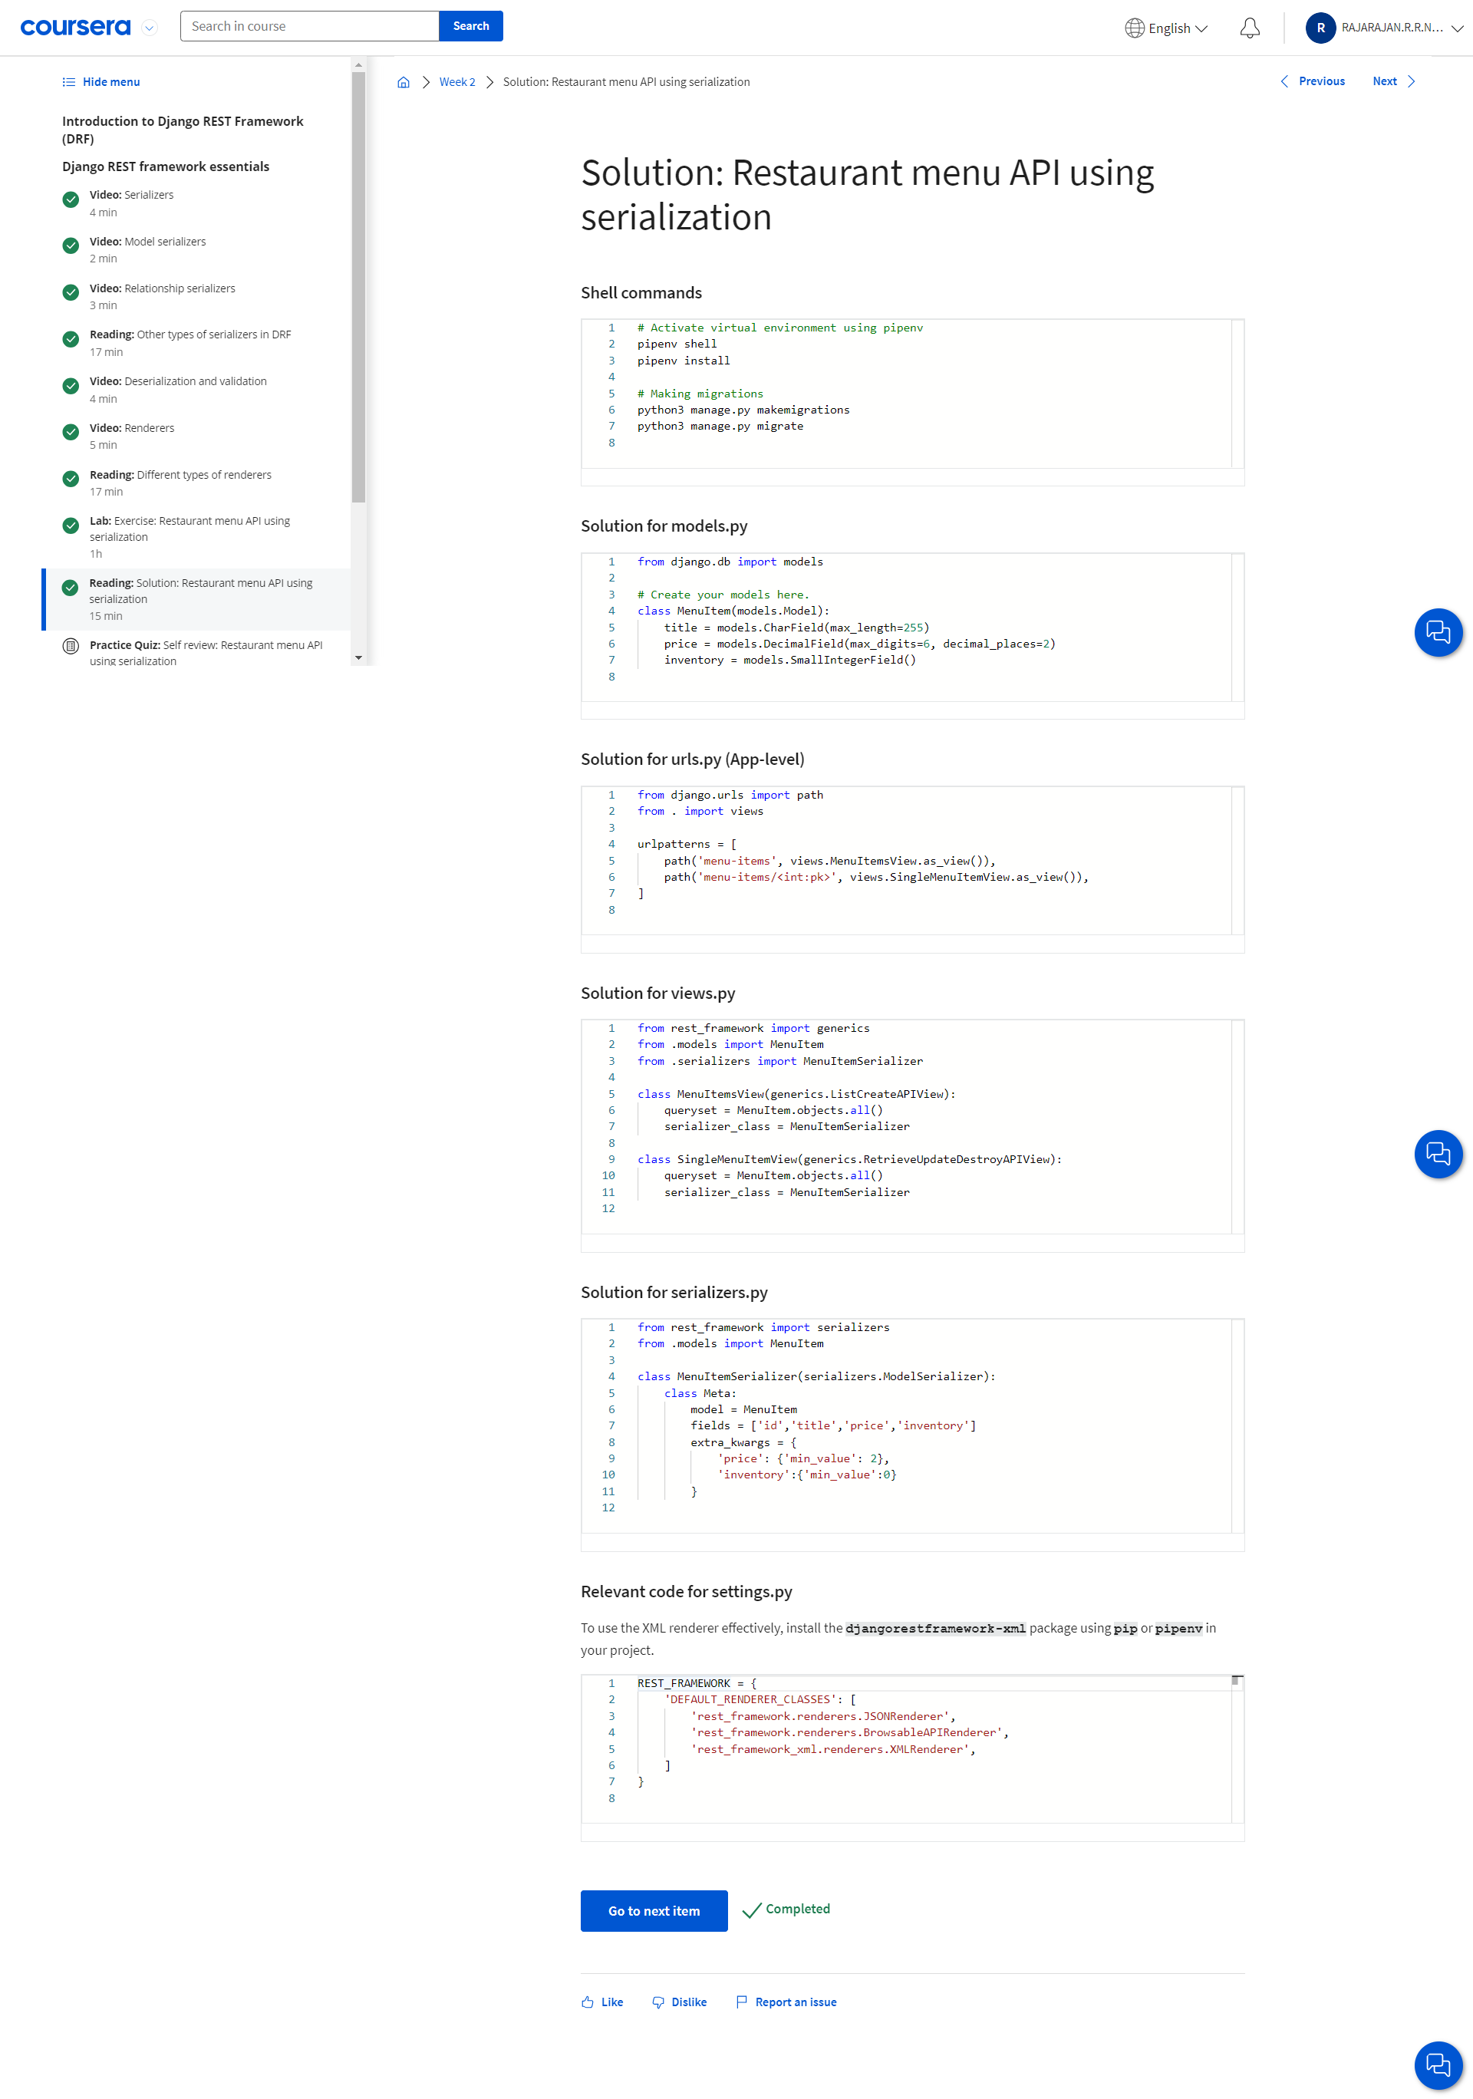

**Filtering and Searching:**

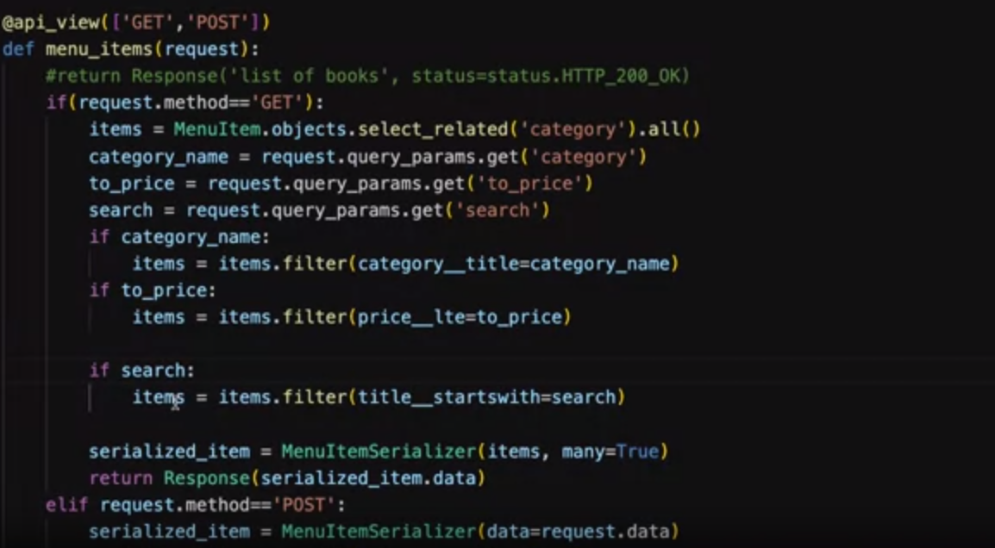

**The query_params.get() method is a convenient way to retrieve query parameters from an HTTP request in Django REST Framework (DRF). It allows you to access the query parameters passed in the URL query string and provides a default value if the parameter is not present.**

[**https://api.example.com/users?name=John&age=30&city=New+York**](https://api.example.com/users?name=John&age=30&city=New+York)

In this URL:

* https://api.example.com/users is the base URL of the API.
* ? indicates the start of the query parameters.
* name=John, age=30, and city=New+York are query parameters. Each parameter consists of a key-value pair separated by =. Multiple parameters are separated by &.

Code:

**if category_name:**

**items = items.filter(category__title = category_name)**

filter(): This is a method used in Django ORM (Object-Relational Mapping) to filter querysets based on certain conditions.

category__title: This is a lookup that allows you to filter based on related fields. In this case, it's filtering based on a field named "title" of a related model called "category", check in models.py. The double underscore "__" is used to traverse relationships between models.

Category_name: This is a variable (or value) that you're filtering against. It represents the value you want to match in the "title" field of the related "category" model.

For price we use __lte (less than equal to), so that we can filter under the given price. If we didn’t give __lte it will exactly give the product that has a given price (price=to_price).

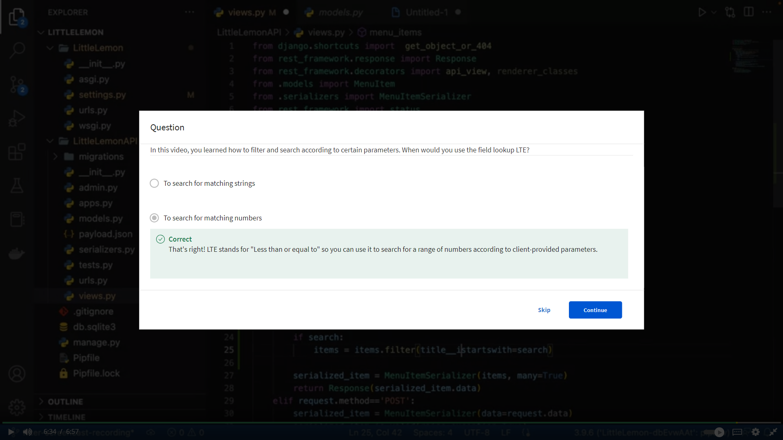

**field__startswith:** This is the lookup syntax. It specifies the field (field) you want to filter on, followed by "__startswith", indicating that you want to filter based on whether the value of that field starts with a specific substring.

**Ordering or Sorting:** 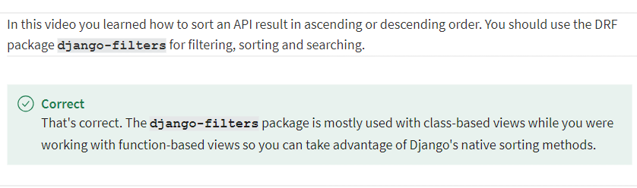

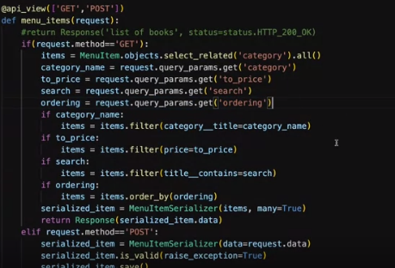

order_by is used to order the values in ASC order with a given field inside the function. IF we want in DSC order the we need to enter symbol ( - ) minus in url.

<https://127.0.0.1:8000/api/menu-items?ordering=-price>

What if the client wants to sort the result by two fields:



First the items will sort by price and then sorted by inventory

We need to split the ordering field with comma, and call the order

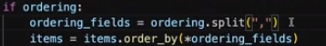.

What if the client wants to sort price in ASC and inventory in DSC:



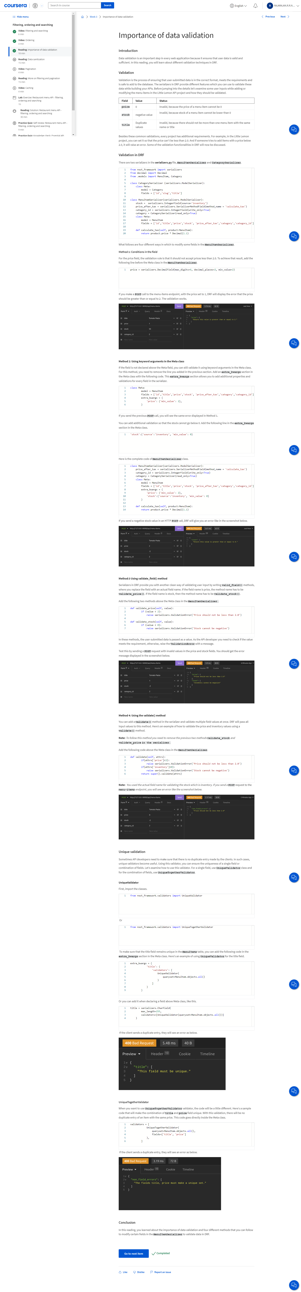 

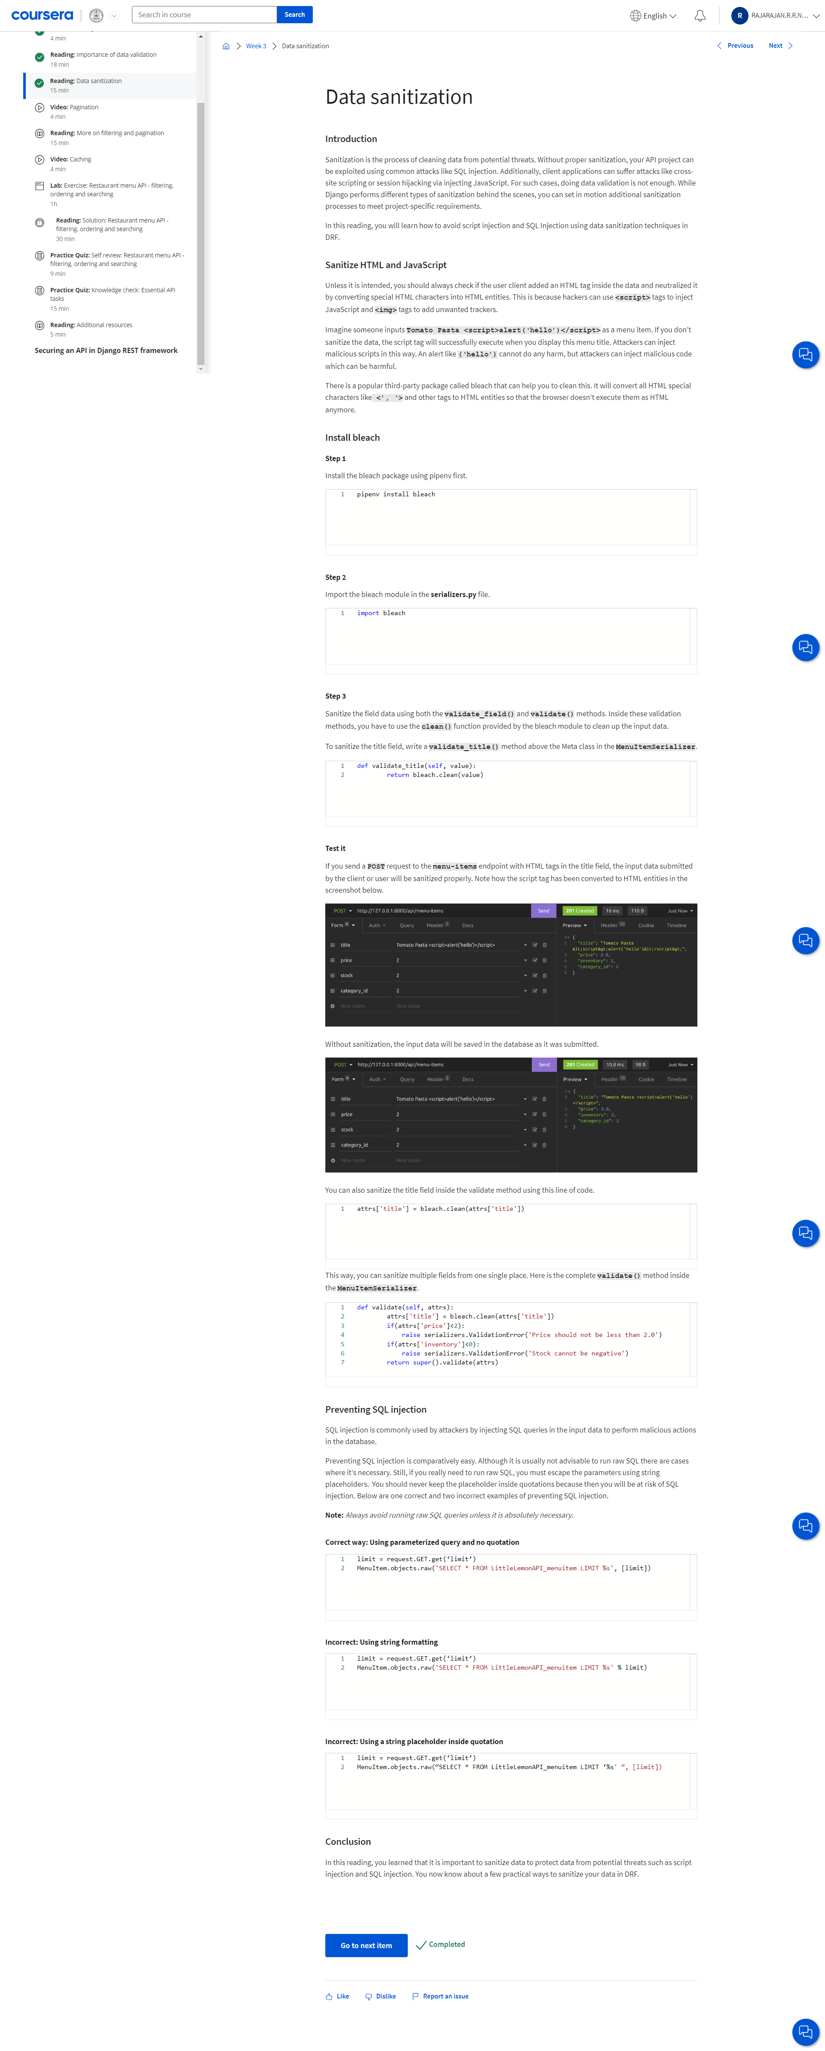

**Pagination:**

Implementing pagination enables APIs to send results in smaller chunks. A security measure to prevent abuse of your API endpoints is we should limit the maximum number of records a client can request per page.





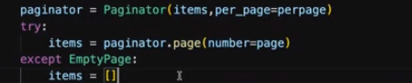

url will be look like this:



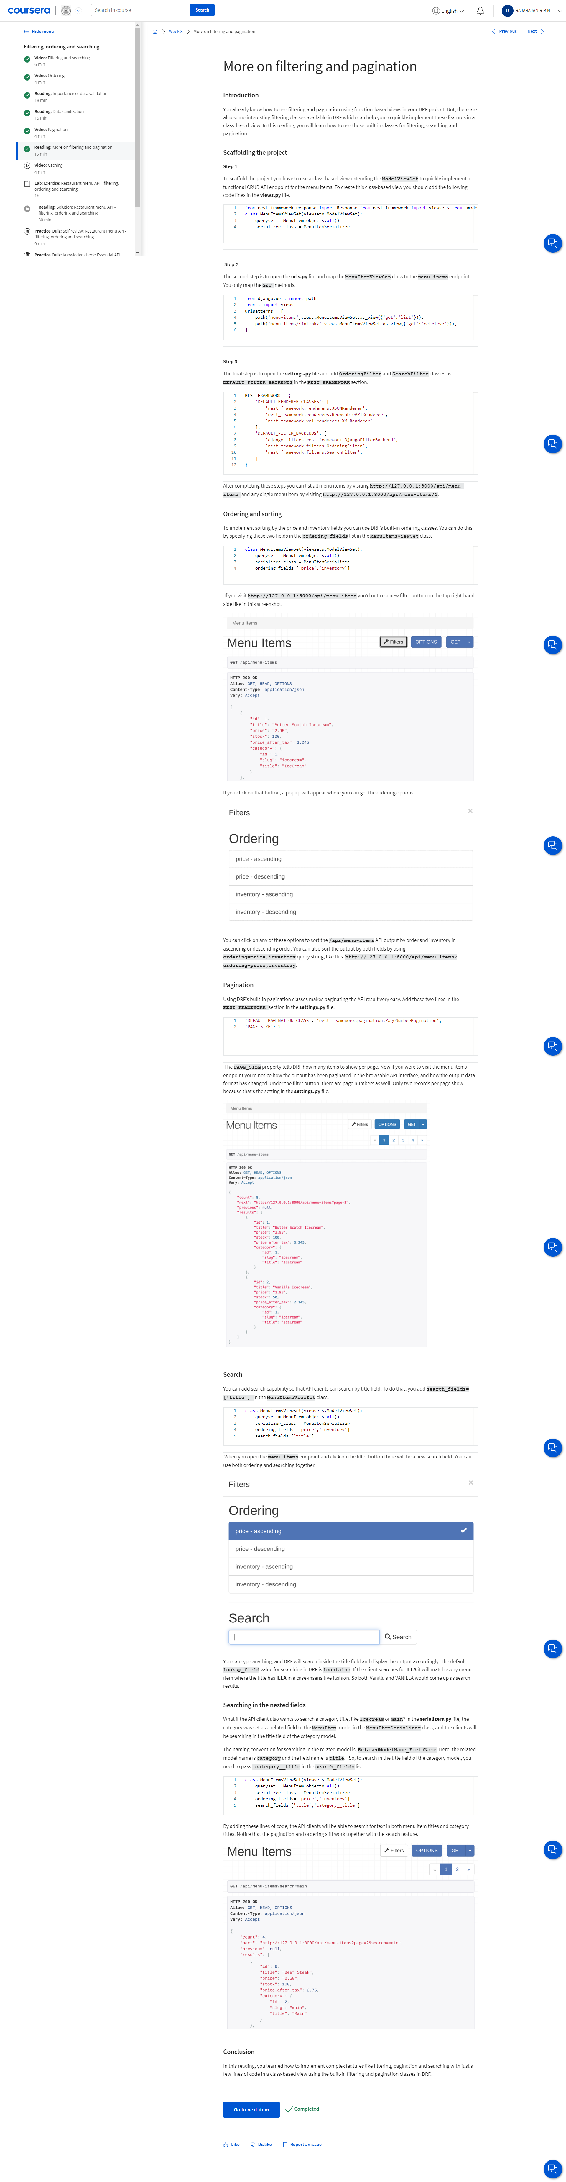

**Caching:**

***Caching can occur in multiple layers like, client side, reverse proxy server, web server and database server.***

In Django REST Framework (DRF), caching refers to the process of storing frequently accessed data or responses in memory or on disk to improve performance and reduce server load. Caching can be applied at various levels within a DRF application to cache entire responses, individual views, or specific data.

**Here's how caching can be implemented in DRF:**

1. **View-Level Caching:**

DRF provides decorators and mixins for caching individual views or viewsets. You can use the @cache_page decorator or the CacheResponseMixin to cache the entire response for a specific view or viewset.

**Example:**

from django.views.decorators.cache import cache_page

from rest_framework.views import APIView

class MyView(APIView):

@cache_page(60) # Cache the response for 60 seconds

def get(self, request):

# Your view logic

1. **Object-Level Caching:**

You can use third-party caching libraries like django-cacheops or django-cache-machine to cache individual model instances or querysets retrieved from the database. These libraries integrate with DRF's serializers to cache serialized data.

Example:

from cacheops import cached_as

from .models import MyModel

from .serializers import MyModelSerializer

@cached_as(MyModel, timeout=60) # Cache queryset for 60 seconds

def get_cached_data():

queryset = MyModel.objects.all()

serializer = MyModelSerializer(queryset, many=True)

return serializer.data

1. **Response Caching Middleware:**

Django provides middleware classes like django.middleware.cache.FetchFromCacheMiddleware and django.middleware.cache.UpdateCacheMiddleware for caching entire HTTP responses. You can configure these middleware classes in your Django settings to cache responses at the middleware level.

MIDDLEWARE = [

# Other middleware classes

'django.middleware.cache.UpdateCacheMiddleware',

'django.middleware.cache.FetchFromCacheMiddleware',

]

1. **Cache Backends:**

DRF supports various cache backends provided by Django's caching framework, such as in-memory caching (django.core.cache.backends.locmem.LocMemCache) and disk-based caching (django.core.cache.backends.filebased.FileBasedCache). You can configure the cache backend and settings in your Django settings file.

**Example (settings.py):**

CACHES = {

'default': {

'BACKEND': 'django.core.cache.backends.locmem.LocMemCache',

'LOCATION': 'unique-snowflake',

}

}

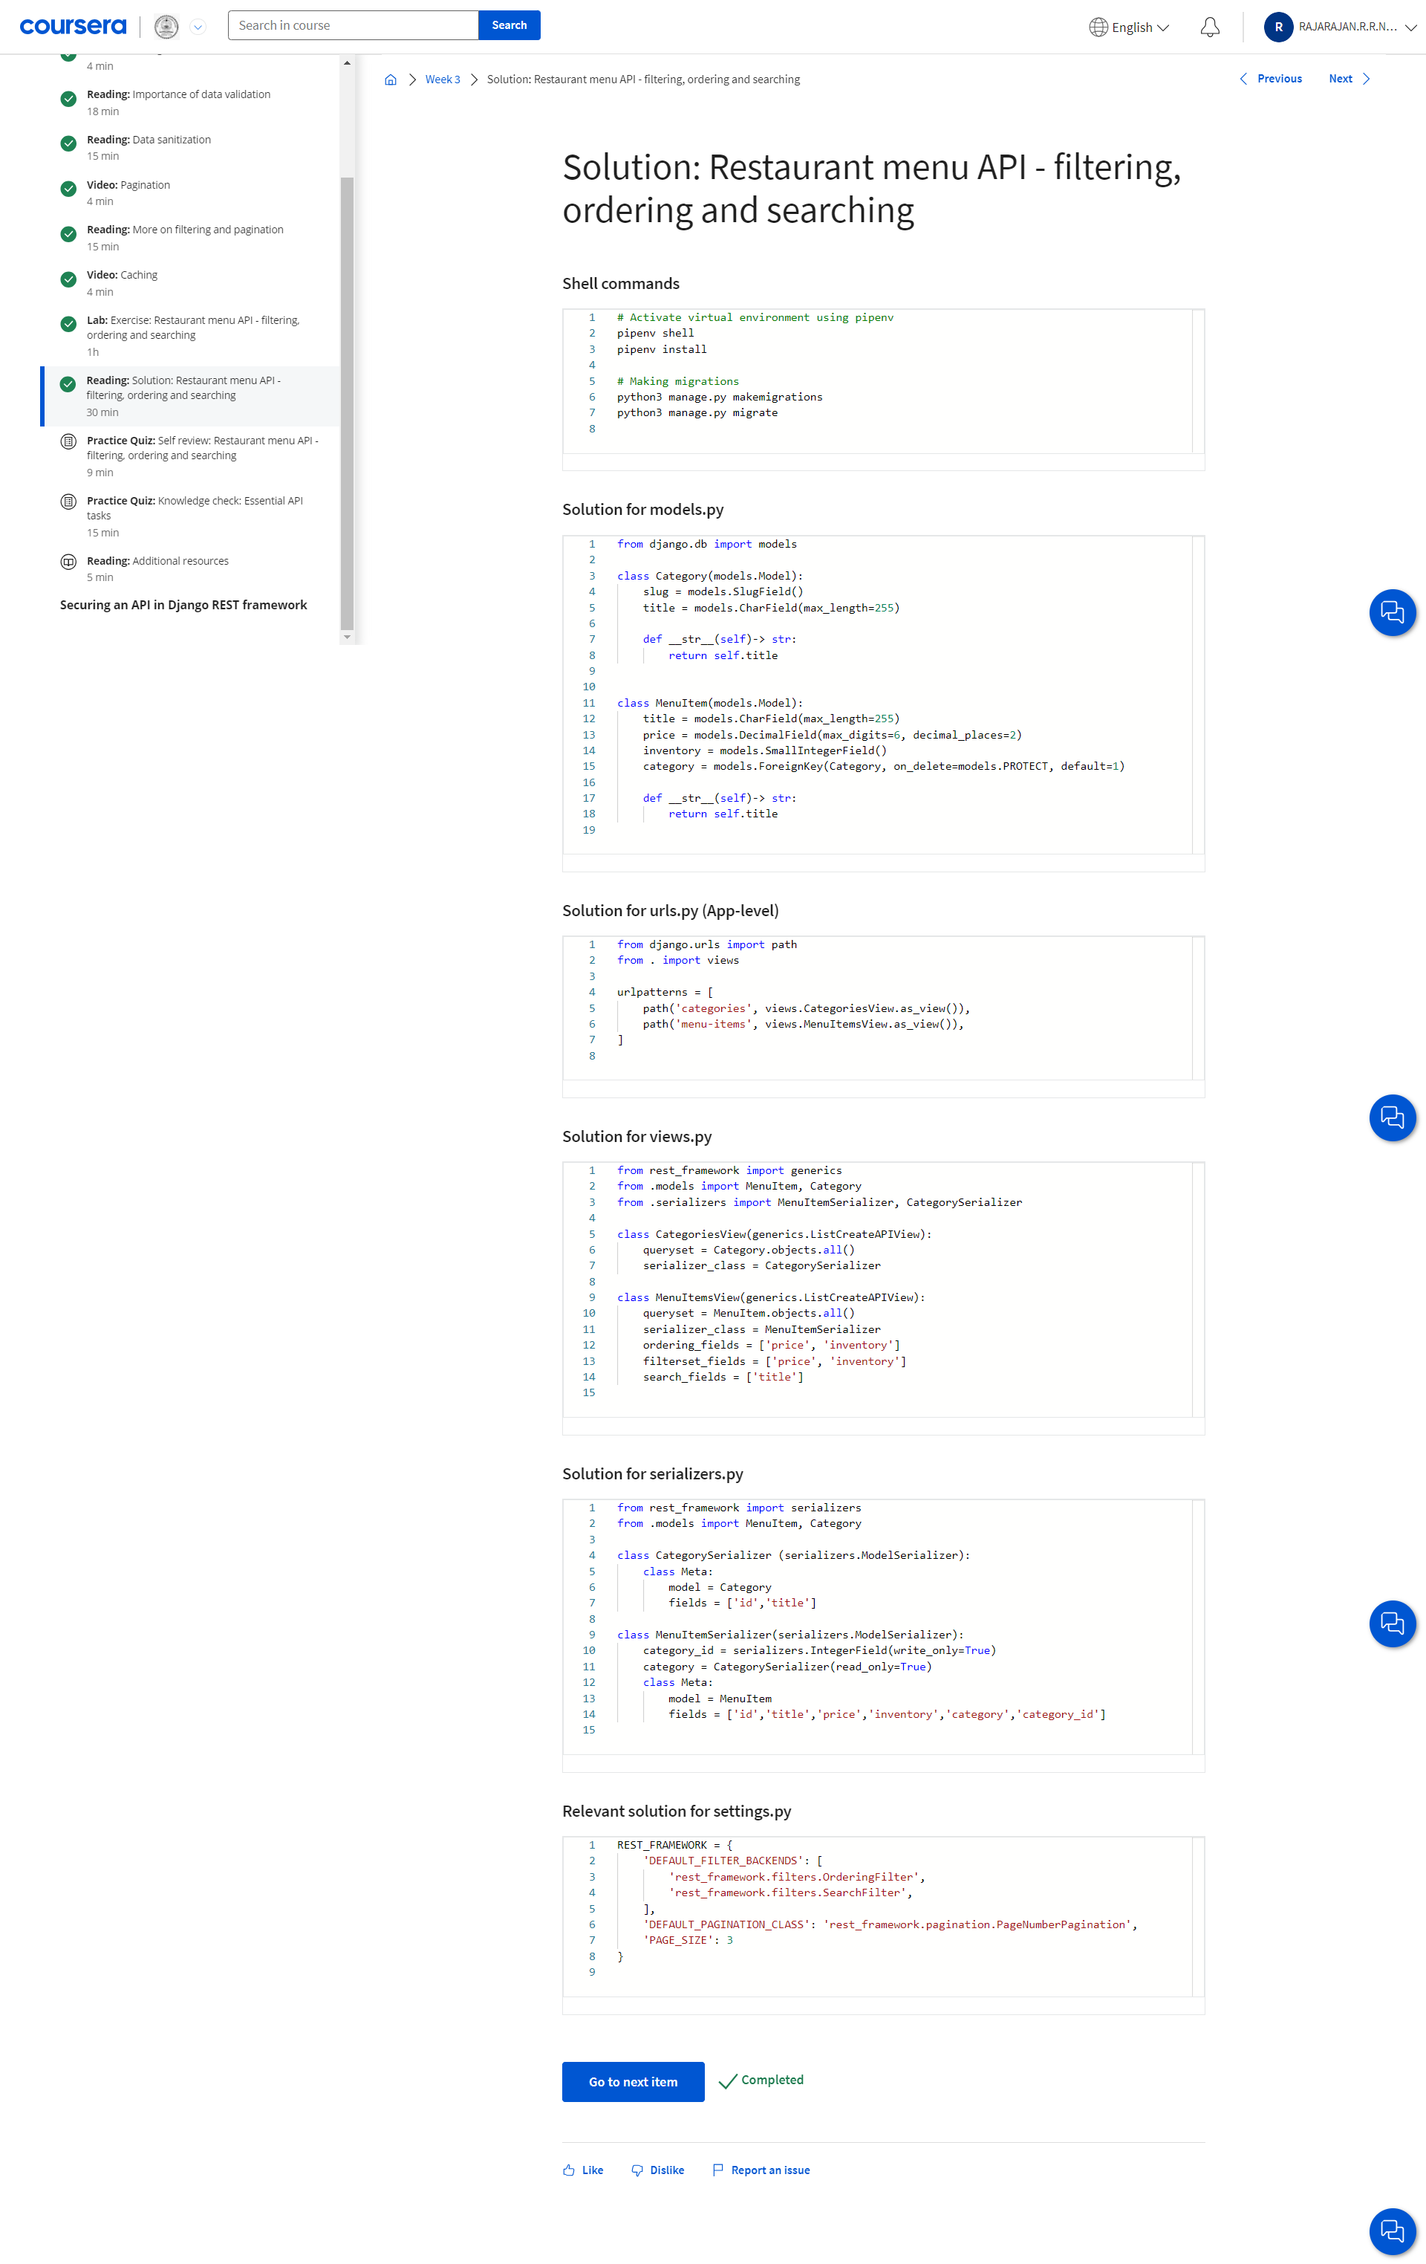

**Token Based Authentication:**

In this approach, users send their usernames and passwords once. If the credentials are okayed, the server generates a unique piece of string. This token is long, hard to read and contains alphanumerical characters and symbols. The server can decide for how long a token will be valid and when it expires. The client sends new API requests and includes this token in the header. Server-side scripts then check if the token is valid, or if it has expired, then it finds which user this token belongs to. This token is validated with the help of token authentication class in the auth token app provided by DRF. If everything is okay, the API will run on behalf of that user. The authentication process is now done using the token, and you avoid sending the username and password every time.

Practical:

Open settings.py and “rest_framework.authtoken” in the INSTALLED_APPS

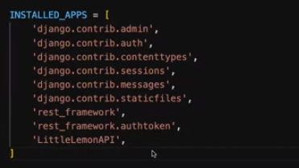

It will add column in Admin page to add or change the token for the users:

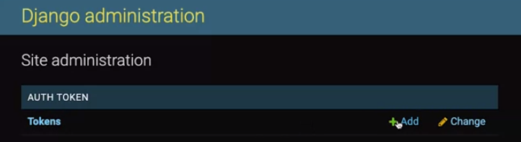

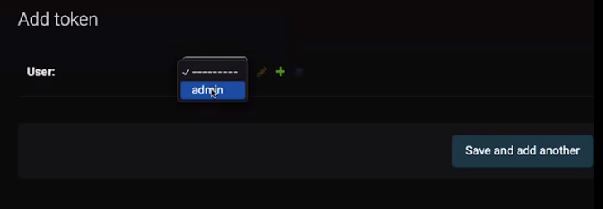

Once we give the option Save, it will look like this:

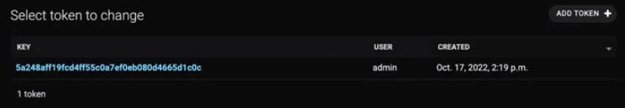

Coding: views.py

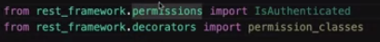

To add the permissions class decorator so that only authorized clients can access the API endpoint:

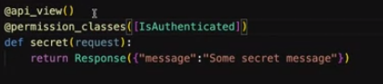

If we test the code by giving the url in Insomnia without giving credentials, we will get:

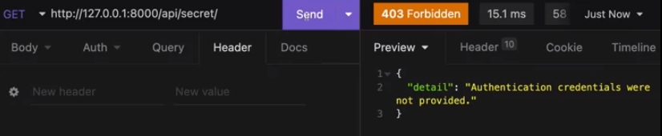

We have to tell the DRF that we are using the token based authentication, so add the code in REST_FRAMEWORK section of settings.py

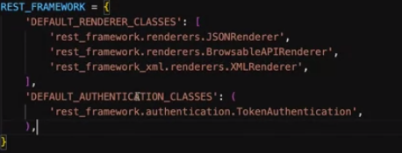

And go to admin page and copy the token of admin credentials that we have created above and open the Insomnia and select Bearer token from Auth tab and paste the token that we just copied earlier and write “Token” in the prefix field.

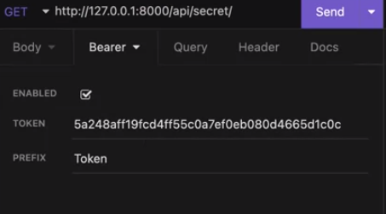

**And header for this send request will be like:** Authentication: Token (Alphanumerical token)



After authentication via token, we got the message:

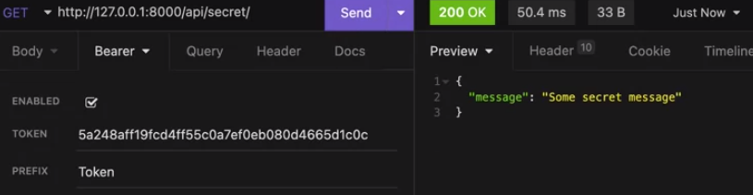

This the process to create token in admin page.

To create token from API end, we need to add some code in urls.py (app level)

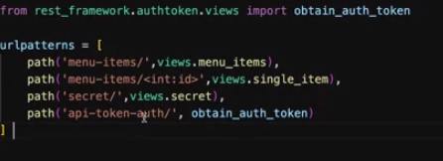

After that we’ve to send the request by giving the URL and we’ve to give username and password under the form url encoded option that you will get in body tab in Insomnia to check if it is creating the token if the credentials are valid.

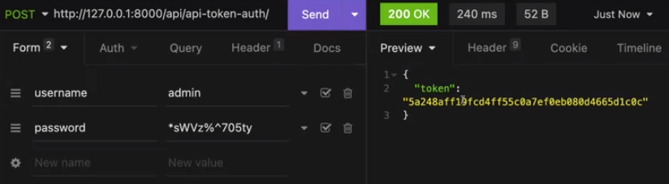

User roles: (Authorization)

Go to admin page and create one group named “Manager” and add one user In that group.

Then go to views.py file and add this code to check if the user has assigned to Manager role.

If yes, the message will print in Insomnia (we need to authenticate via token of the particular user) otherwise the 403 error will raise.

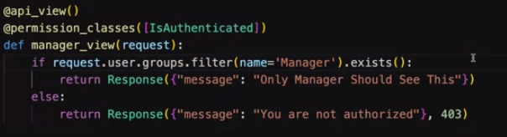

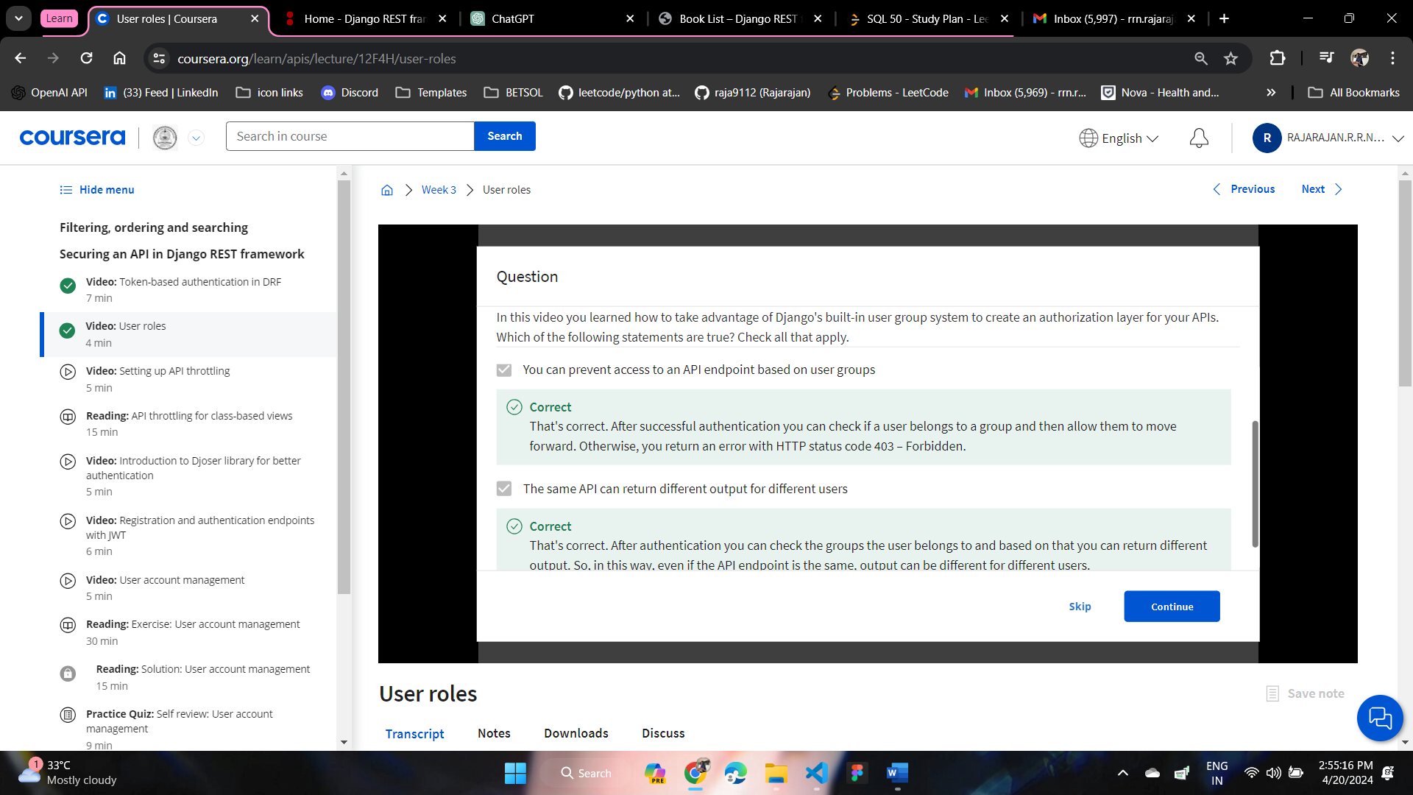

**Throttling or rate limiting:**

There are two types of throttling, one for unauthenticated another one for authenticated ones.

**Throttling,** also known as rate-limiting, is a technique used to control the rate of requests made to an API by limiting the number of requests that a client can make within a specified period of time. The purpose of throttling is to prevent abuse, ensure fair usage of resources, and protect the server from being overwhelmed by too many requests.

**Here's how throttling typically works:**

**Set Limits:** The API provider defines limits on the number of requests that clients can make within a certain timeframe. For example, the limit might be set to allow 100 requests per hour per client.

**Track Requests:** The server tracks the number of requests made by each client, usually identified by their IP address or API key.

**Enforce Limits:** When a client makes a request, the server checks if the client has exceeded their allotted quota. If the client has reached their limit, the server rejects the request with a response indicating that the client has been throttled.

**Reset Limits:** After the specified time period elapses (e.g., one hour), the request quota resets, and the client can make new requests up to the limit again.

**Throttling can be implemented at different levels:**

**Global Throttling:** Limits the total number of requests allowed across all clients.

**Per-Client Throttling:** Sets individual limits for each client based on their identity (e.g., IP address, API key).

**Per-Endpoint Throttling:** Sets different limits for specific API endpoints based on their importance or resource intensity.

Throttling helps ensure the reliability and performance of an API by preventing abuse and protecting against denial-of-service (DoS) attacks. It also encourages developers to use APIs responsibly and efficiently. However, it's essential to set throttling limits carefully to avoid inadvertently restricting legitimate usage or causing frustration for users.

To implement Throttling, we have to add DEFAULT_THROTTLE_CLASSES in REST_FRAMEWORK section in settings.py

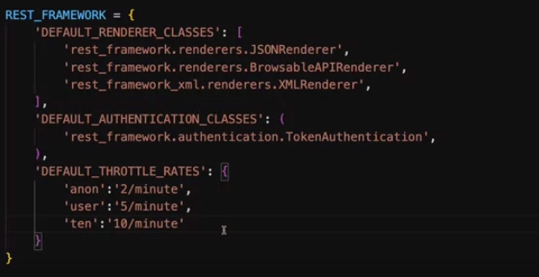

**Anon** for anonymous users, **user** is for authenticated users and **ten** is like you set the limits and like this and you can give the module in decorator for any authenticated or unauthenticated user,

views.py

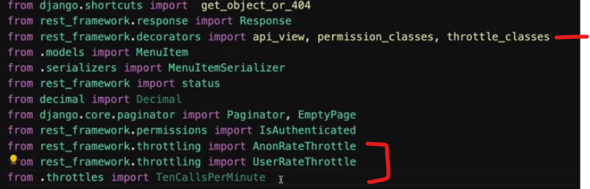

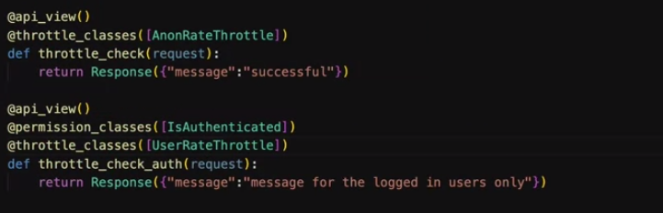

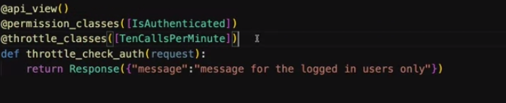

We can change from UserRateThrottle to TenCallsPerMinute . Actually we setting this directly

You can give the respective url in insomnia and check the limit is working for authenticated users by authenticate via token.

After 10 calls, the it will give throttling message:

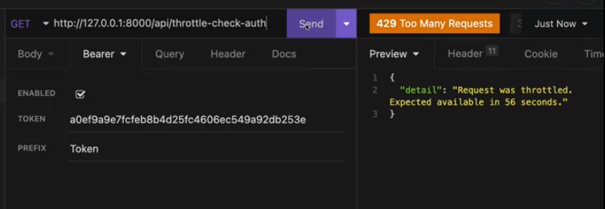

For anonymous users we can directly check it in browser by copy pasting the link and refreshing the page.